Custom made golf stand bag
1. Dual Density comfort strap: utilizes two materials for added comfort and stability
2. 14-Way Organizational top
3. Large internal insulated cooler pocket
4.. Comfortable Transport with strap on back, rain Hood included
5.. Integrated top handle and 14-way full length dividers
​
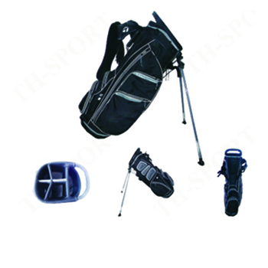
More information please click: www.tt-golf.com

